 | - To perform clustering operations using Weka

Name of Student | Hardik Prajapati | Roll No. | 9152
Sign here to indicate that you have read all relevant material provided /available on Moodle while performing and writing this experiment |  | Sign:

Late Submission Details (if any)
Reason(s) of late submission | Date of practical performance | Date of practical submission

References used
1 | Name and author of reference book(s) with page nos.
2 | Name and roll nos. of the peers whose help you have taken (if any)

Rubrics for assessment of Experiment:
Indicator | Poor | Average | Good
Timeliness  Maintains Experiment deadline (3) | Experiment not done (0) | One or More than One week late (1-2) | Maintains deadline (3)
Completeness and neatness  Complete all parts of Experiment (3) | N/A | < 80% complete (1-2) | 100% complete (3)
Originality  Extent of plagiarism (2) | Copied it from someone else (0) | At least try to implement but could not succeed (1) | Implemented (2)
Knowledge  In depth knowledge of the Experiment (2) | Unable to answer any questions (0) | Unable to answer few questions (1) | Able to answer all questions (2)

Assessment Marks:
Timeliness
Completeness and neatness
Originality
Knowledge
Total

Signature of Teacher with date

1. | Course, Subject & Experiment Details

Course & Branch | T.E. (ECS) | Estimated Time | 02 Hours Per Week
Current Semester | Semester V | Subject Name | DWM
Chapter No. & Unit | 6 | Chapter Title | Data clustering
Experiment Type | Software Performance | Subject Code | ECC 604

2. | Aim & Objective of Experiment
- Understand data clustering
3. | Expected Outcome of Experiment
- Demonstrate different types of data clustering operation using Weka
- Compare the performance of different types of data clustering operation
4. | Theory and procedure of the experiment

Solve Exercise 1 and 2 from the following document:
https://drive.google.com/file/d/1YRP0UlhVaB6Jwg1AhjFhY_hyco5OSJM9/view?usp=share_link

4. | Output

Attach the screenshots of output above exercises and comment on the result of each exercise

EXERCISE 1 SCREENSHOTS:

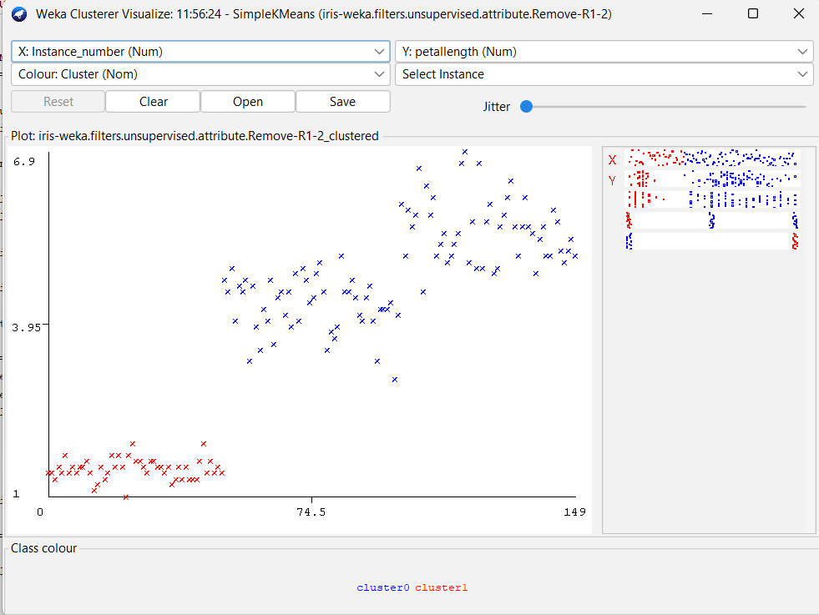
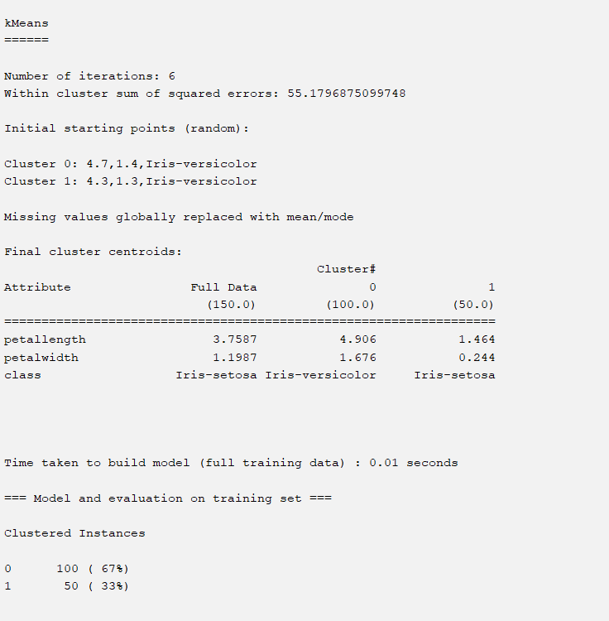

3 clusters:
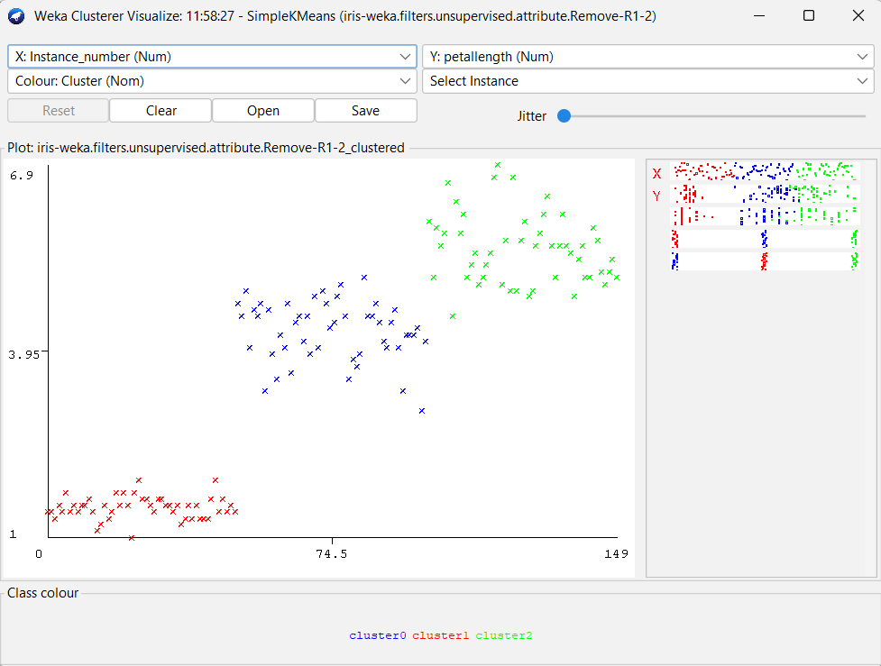
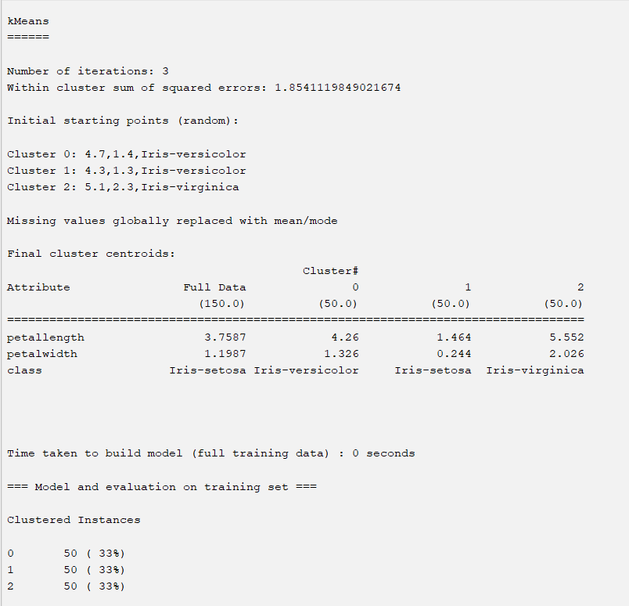

4 clusters:
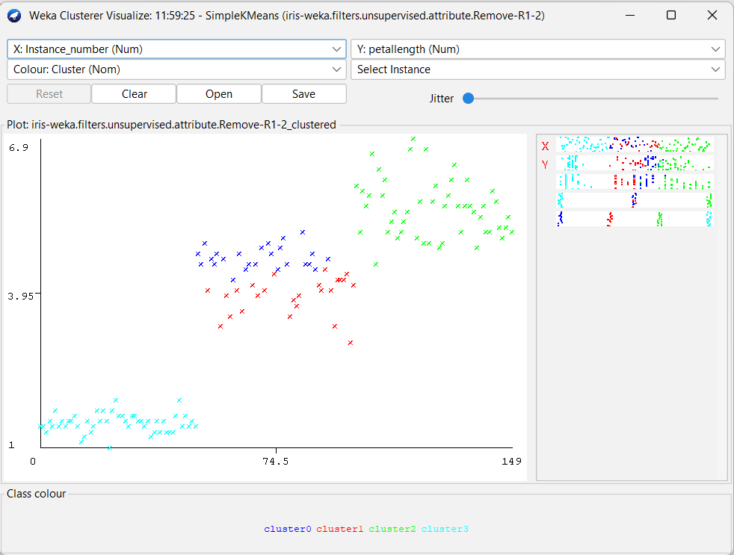
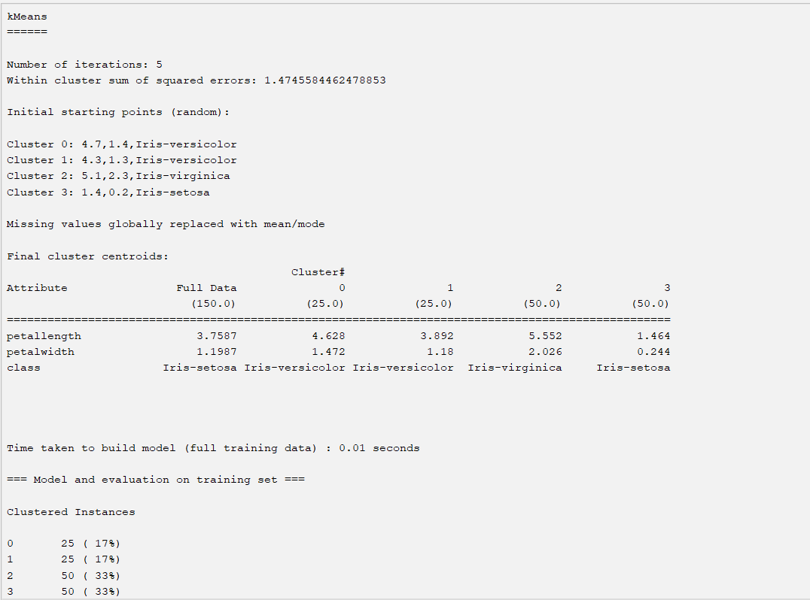
5 clusters:
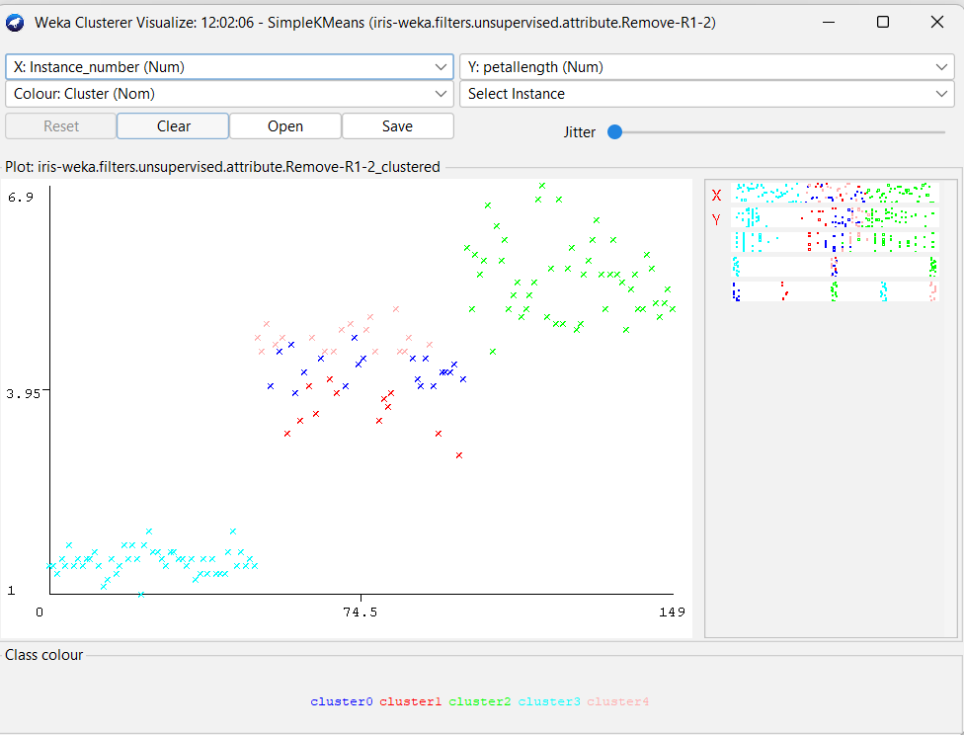
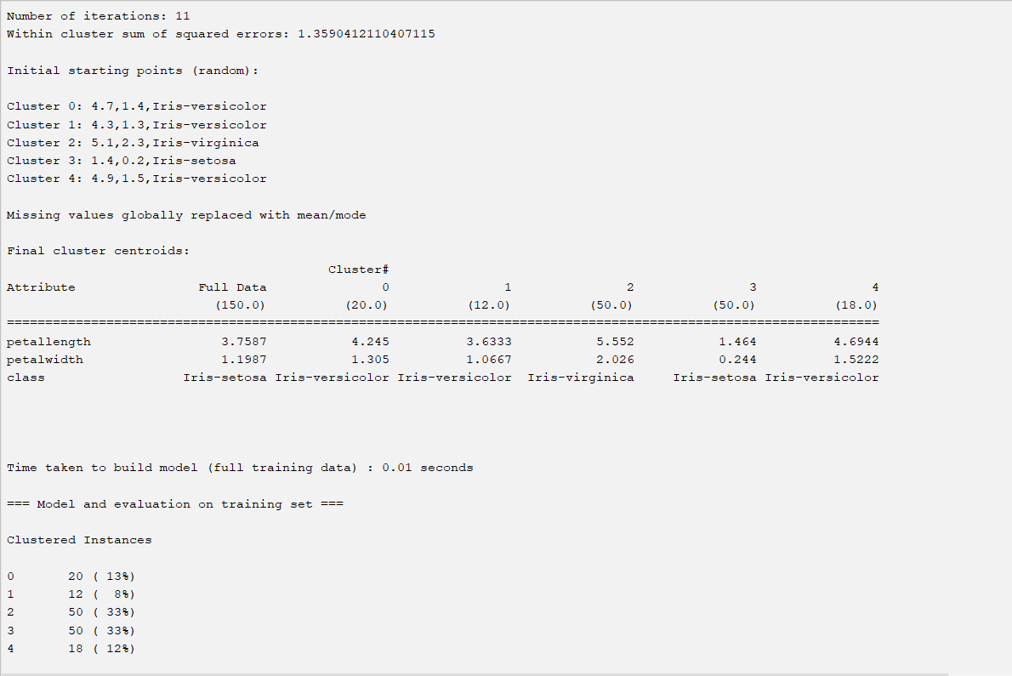

K-means++:
2 clusters:
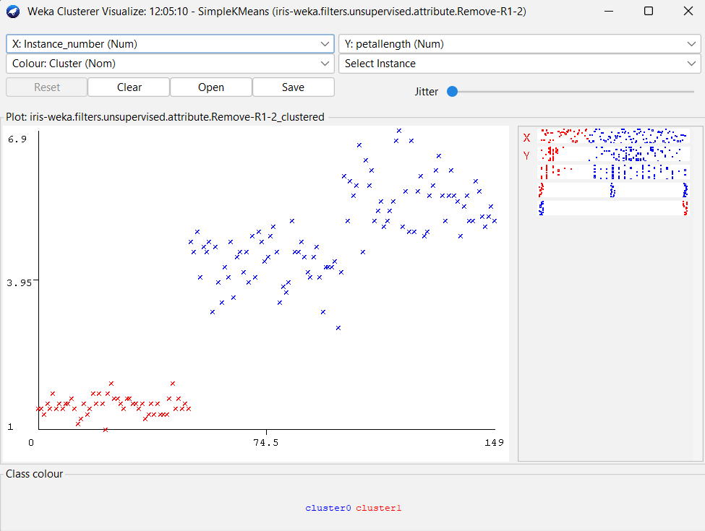
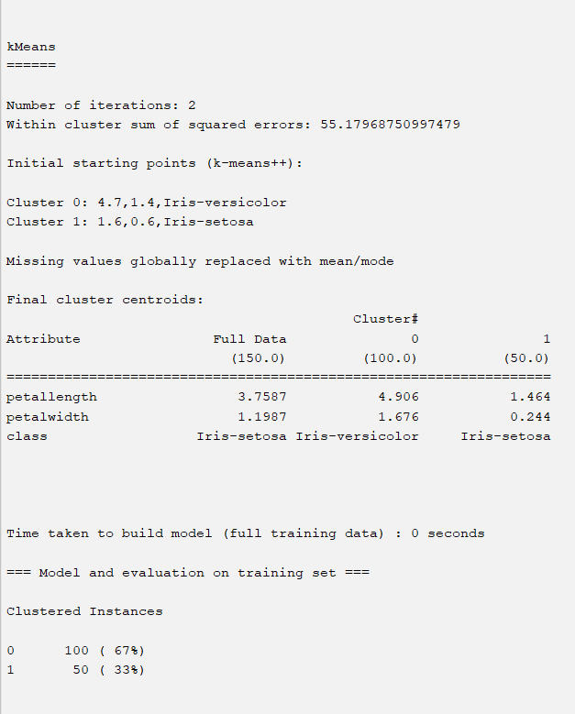

Canopy (2 clusters):
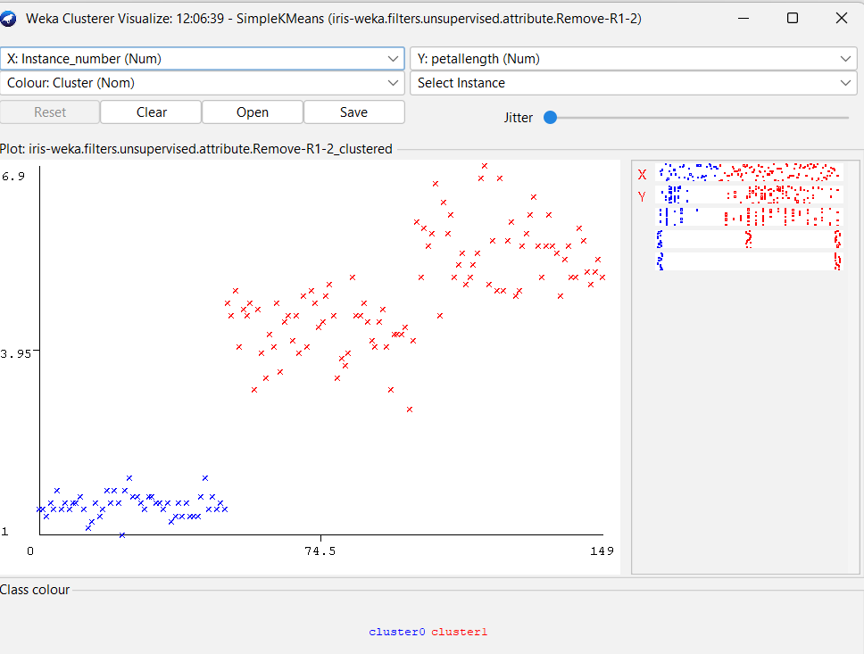
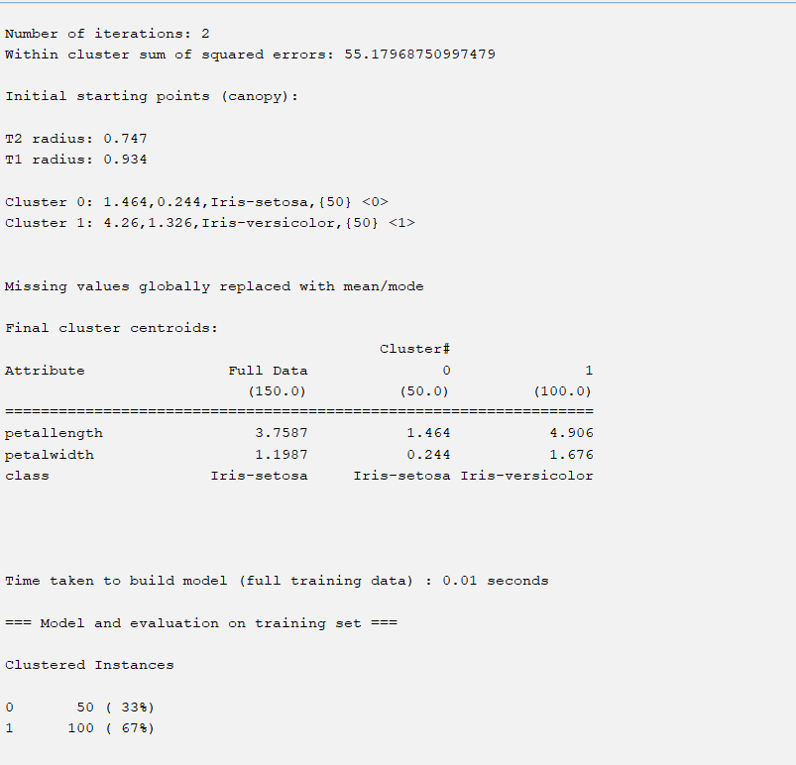

Farthest First (2 clusters):
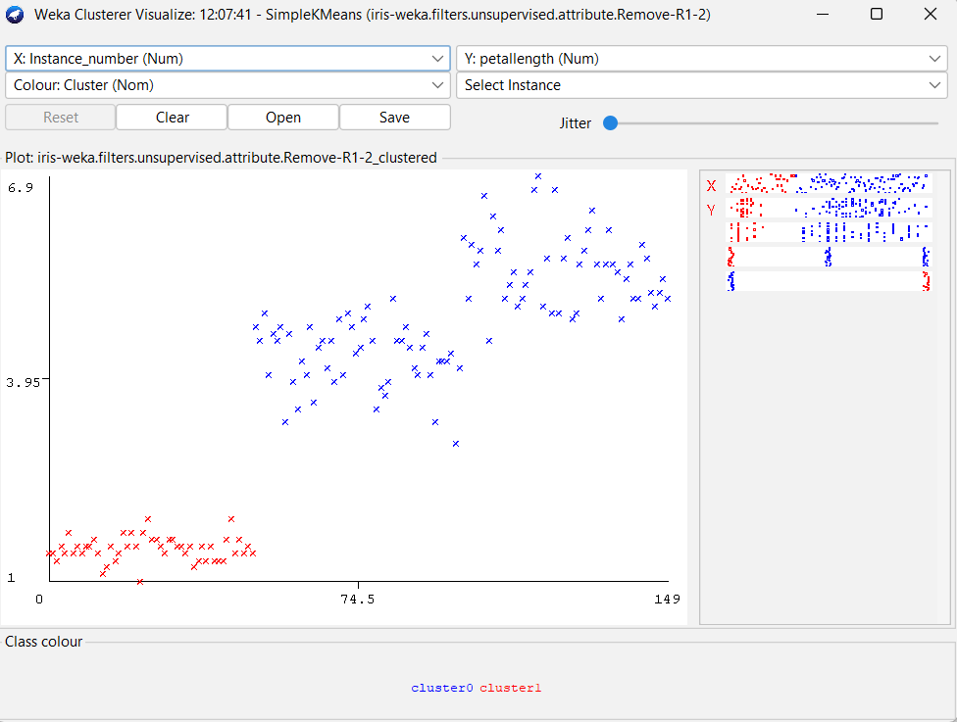
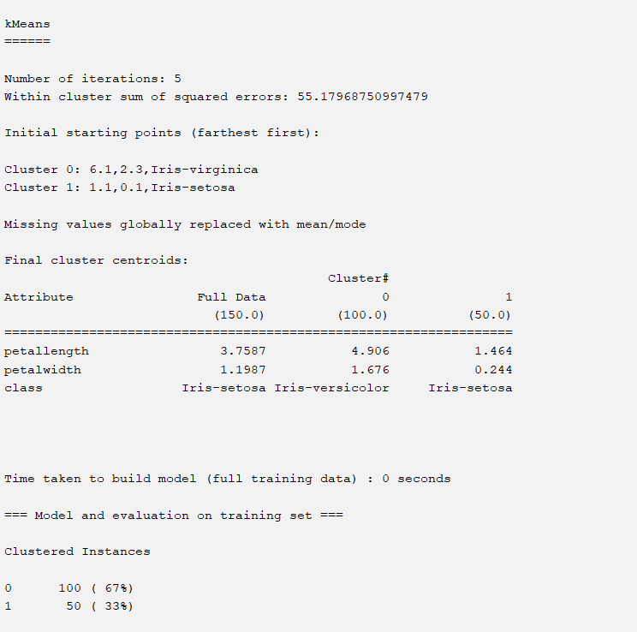

EM:
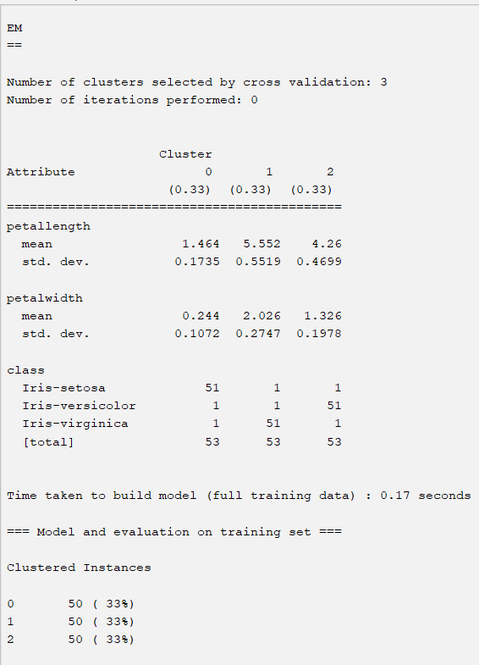
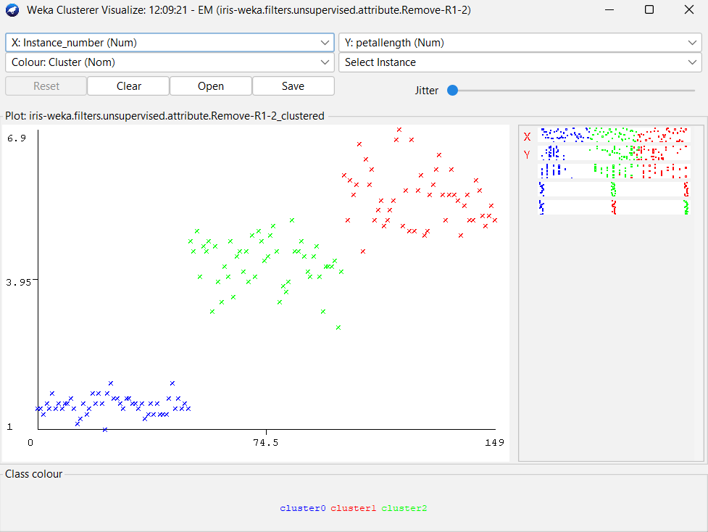

EXERCISE 2:

SINGLE LINK:

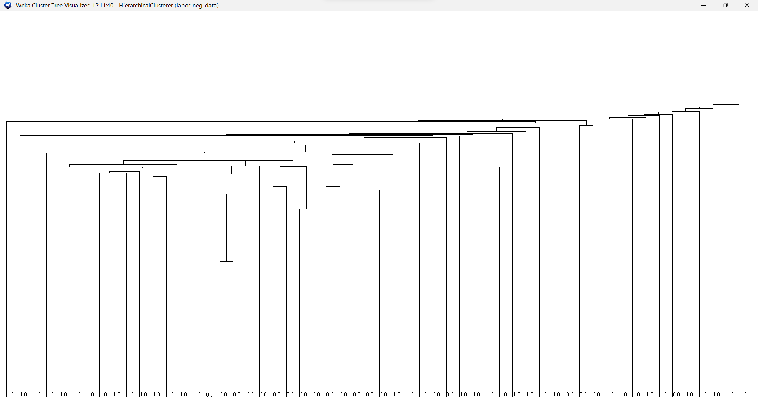

COMPLETE LINK:
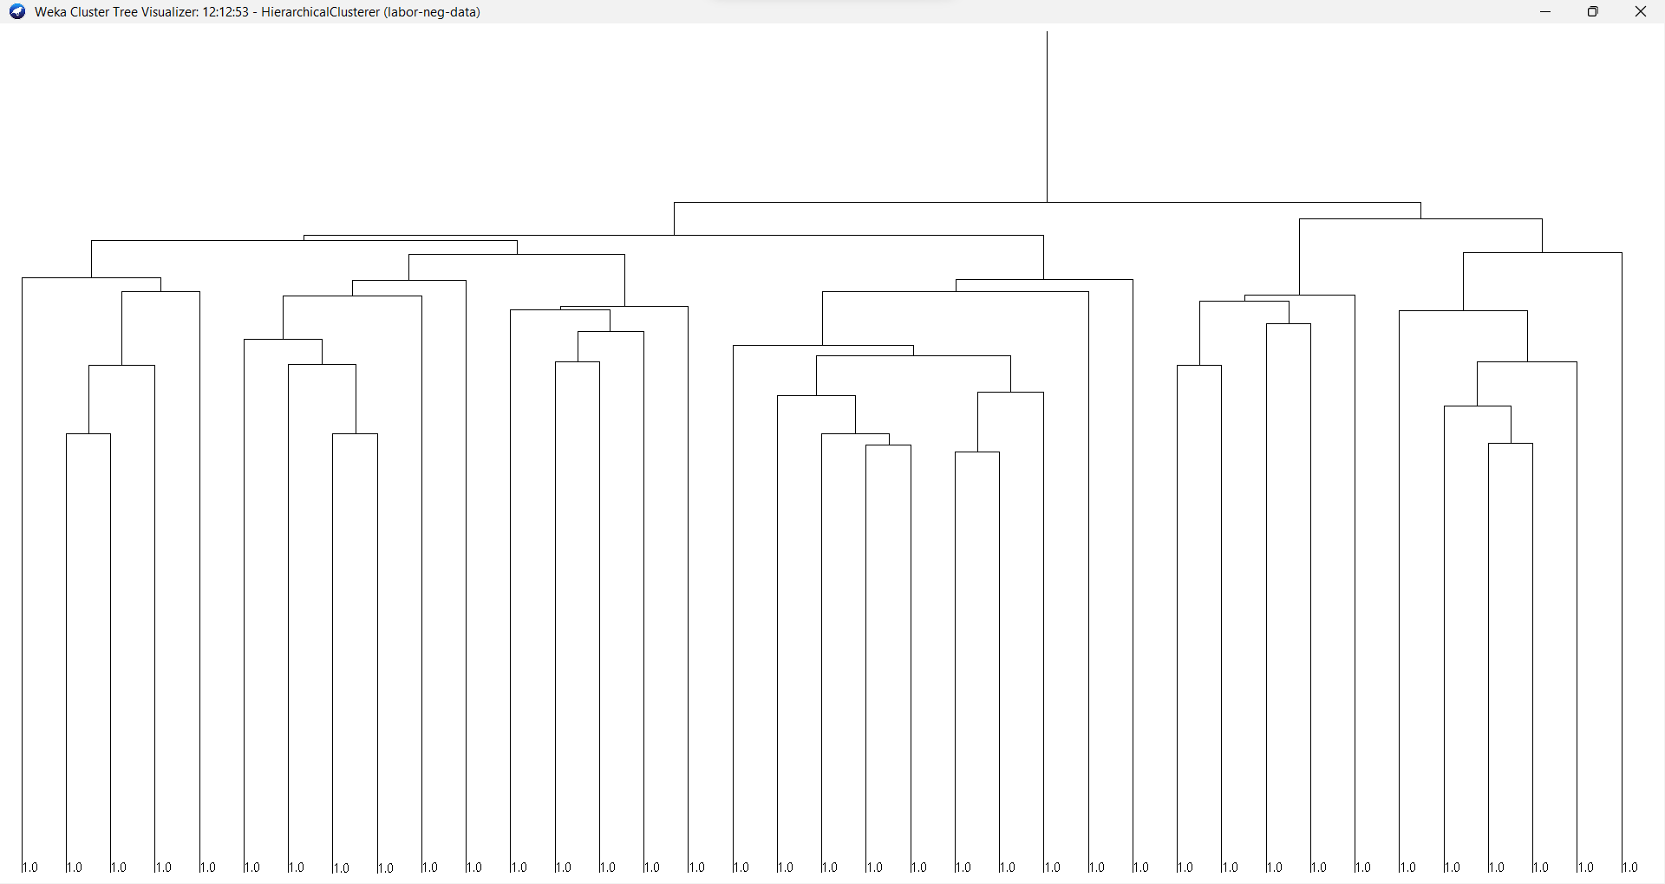

AVERAGE LINK:
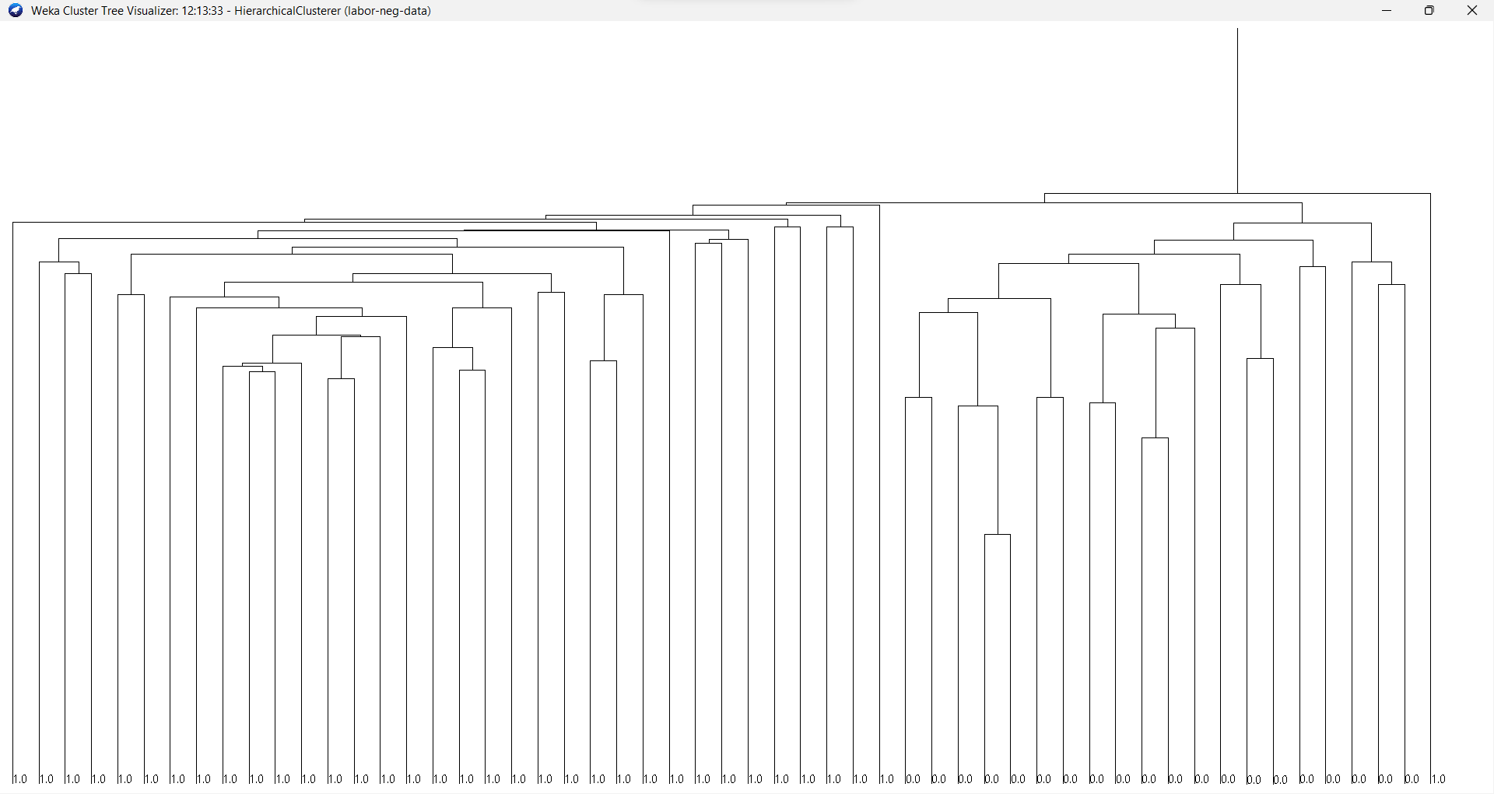
5. | Conclusions & Inferences

From this experiment, we have learnt how to visualize clusters and link wise hierarchical trees

6. | Post Lab exercise

- Describe different methods used for centroid initialization, mentioned in this write-up

******************

